1.Chat

Let’s quickly create an app similar to Slack or MS teams and even more like rocket chat. No experience developing. With the right help I think it’s difficult but not impossible to do this.

The web app could be written in a mix of JavaScript and ES6, with React. To send it as a desktop app, Electron will be utilized.

The goal is to create a MVP within 3-6 months. Main focus will be to

|  |
| --- |
| *future growth – evolution of app* |
| *Able handle 10k concurrent users* |
| *Real time communication* |
| *Get it built in 3-6 months* |
| *Chat rooms should have enough size and capacity* |
| *Searching across several channels simultaneously* |
| *Scale when load is suddenly increased* |
| *Faster retrieval of message history* |
| *Be able to share messages with multimedia support* |

Functions:

Direct messages and group direct messages

channels

Automatic contact sync

Typing Indicator in a chat app

File sharing

Push notification

End to End Encryption

Search

Integration with email

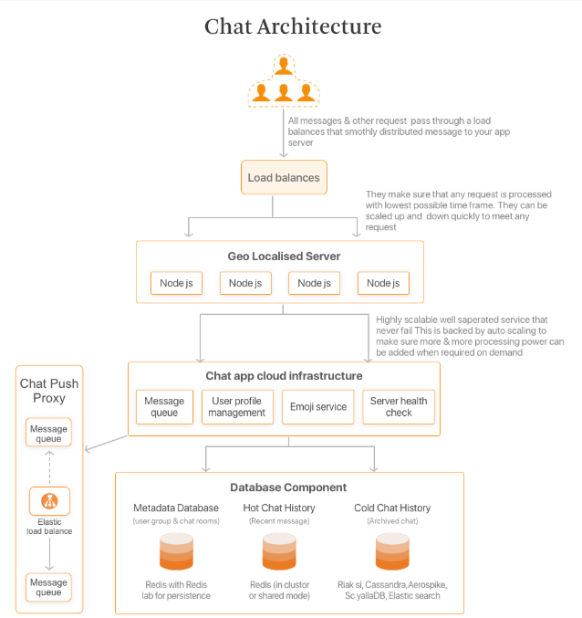

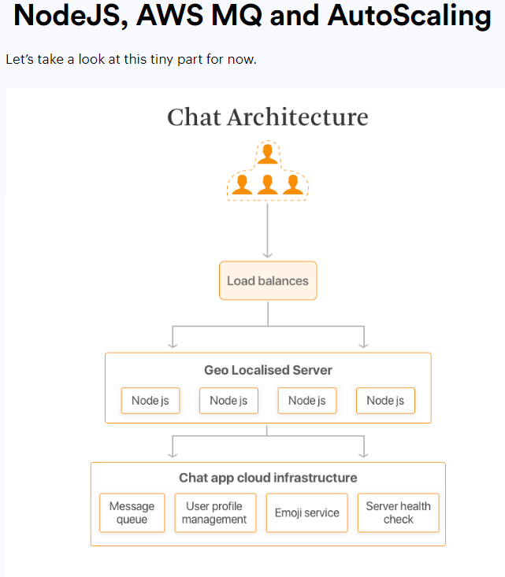

2. Apps

App Directory

Rest API

Extension API

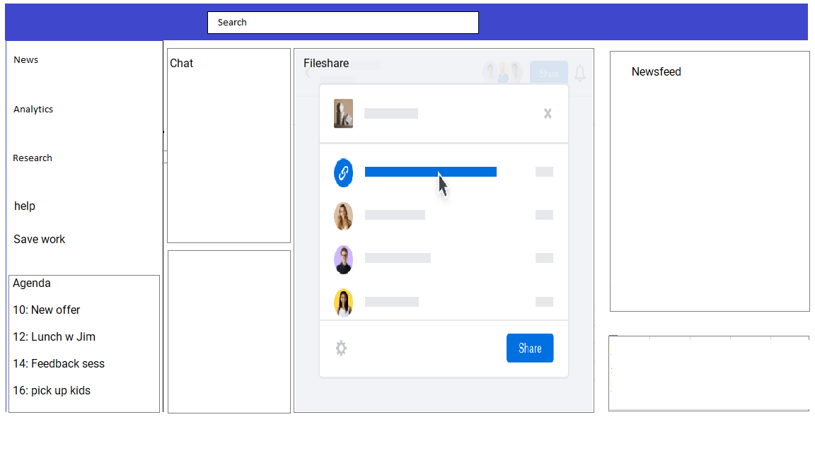

In the app itself there’s the possibility to have multiple screens open at the same time and change their size and shape (like tabs).

<https://www.simform.com/how-to-build-messaging-app-whatsapp-telegram-slack/>

Join me on:

<https://github.com/rubenfunda/snyder>